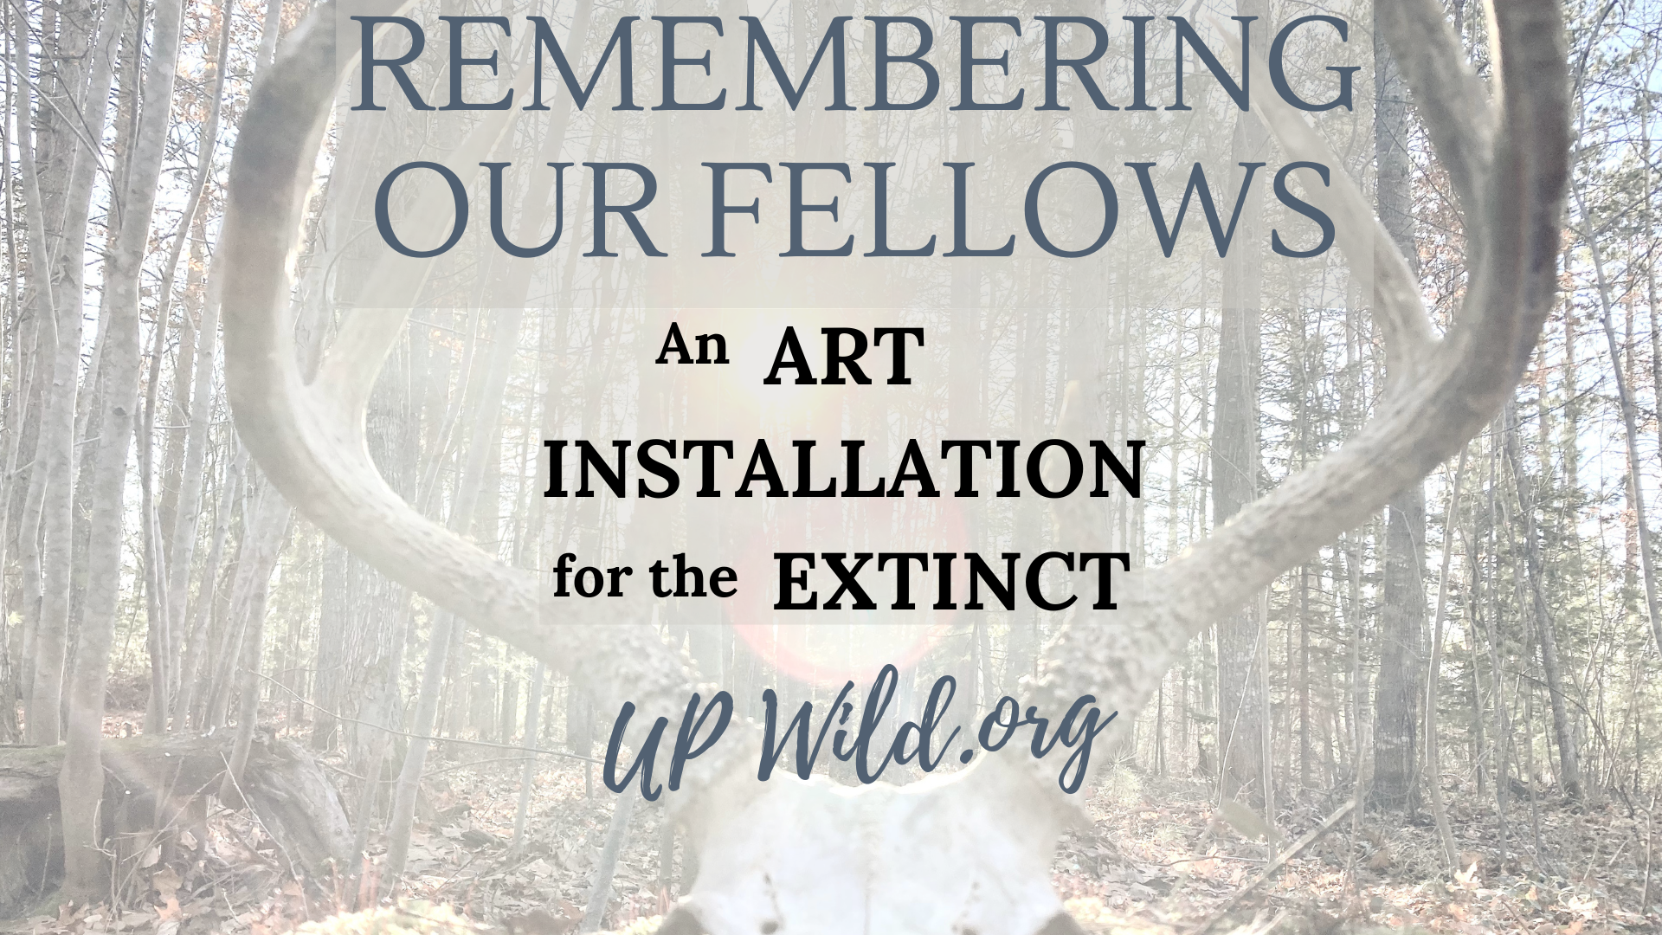

Species Declared Extinct since 2020:
*Displayed on crosses

Ngutu Kākā Plant (2025)

Pieris Wollastoni Winged Insect (2025)

Hawaiian Crow (2025)
Bermuda Hawk (2025)*

New Zealand Ground Bettle (2025)

Conus Lugubris Snail(2025)

Captain Cook’s Bean Snail (2024)
Geneva Winter White Fish (2024)*
Lanai Hookbill Bird (2024)
Mauritius Owl (2024)
Serrasuela Plant (2024)*
Short-Tailed Hopping-Mouse (2024)

Thick-billed Ground Dove (2023)
Ainsworth’s Salamander (2023)*
Choiseul Pigeon (2023)

Achyranthes Mangarevica Plant (2023)

Oceanic Eclectus Bird (2023)

Campo Grande Tree Frog (2023)

Chinese Paddlefish (2022)
Lake Sidi Ali Trout (2022)

Mountain Mist Frog (2022)*

Polynesian Tree Snail (2022)

Syzygium Humblotii Plant (2022)

Wyoming Toad (2022)

Cuban Macaw (2021)

Large Sloth Lemur (2021)

Jamaican Monkey (2021)*

Martinique Amazon Bird (2021)

Mountain Mist Frog (2021)*

Camasey Plant (2021)

Guam Flying Fox Bat (2020)*

St. Helena Darter Insect (2020)

Mauritius Giant Skink (2020)

Bourreria veracruzana Plant (2020)

Rodrigues' Day Gecko (2020)
Splendid Poison Frog (2020)*

Total Declared: 75 in 2020 / 25 in 2021 / 49 in 2022 / 73 in 2023 / 173 in 2024 / 46 in 2025

* Source: International Union for Conservation of Nature’s Red List of Threatened Species
Declaration means no more living members of the species are on Earth in the wild or captivity. New fossil discoveries will also be included. To look up each species go to: https://www.iucnredlist.org

Cultivating Awareness
Members of U.P. Wild Church began prayerfully painting crosses in 2020 in remembrance that each species was made by and belongs to our Creator. According to the International Union for Conservation of Nature, there are more than 172,600 species on their Red List of Threatened Species with more than 48,600 species threatened with extinction. National Endangered Species Day is every third Friday in May. The day is a time to raise awareness about endangered species, celebrate conservation efforts, & encourage people to learn more about protecting vulnerable wildlife & their habitats.
We are called to fall back in love.
By loving that which God has created, out of the same breathe of life in which we were created, we liberate ourselves from the isolation and loneliness of a culture of consumption that places primary value on human-made things. We remember that we are a part of a living breathing eco-system; a community of friends; each bearing witness (in their own way) to holiness. “Ask the animals and they will teach you; the birds of the air, and they will teach you; ask the plants of the earth and they will teach you; and the fish of the sea will declare to you.
Who does not know that the hand of the Creator has done this?” (Job 12)

As you stand before the crosses…
Make a personal connection
- Personally recall the relationship you had with a pet or animal friend.
- Name them.
- Remember a memory of the joy they brought to your life.
- How did they keep you from isolation and despair through their unconditional love and presence?
- Give thanks for them.
- Read this poem silently in your heart:
“If I can stop one heart from breaking, I shall not live in vain; if I can ease one life the aching, or cool one pain, or help one fainting robin, unto his nest again, I shall not live in vain.” – Emily Dickinson

Ritual of Remembrance
Releasing our Grief

In the ancient languages, the word memory means mindfulness
to witness
to grieve.
To witness mindfully is to grieve for what has been lost.

Grief acknowledges what has been lost and ensures that we don’t forget what must be remembered.
We build memorials as places of mourning and memory where grief is given concrete form & we are reminded of our shared loss. Mourning + memory are related.

To counter the amnesia of our times, we must be willing to look into the face of the loss and keep it nearby. We honor the losses and live as carriers of their unfinished stories. This is an ancient thought; how we tend to the dead is as important as how we tend to the living. In our culture, it is easy to discard the ones who went before in all their shapes and ways of living. Yet, they are all ancestors, from the elder white pines that have been cleared for a [Dollar Tree in Harvey] to wetlands filled with [mining waste tailings in Ishpeming].
The dead are among us. And we must not forget them.

Remembering our Fellows is an artistic ritual memorial providing our community an opportunity to collectively grieve the extinction of various plant, animal, and fungal species. ‘Each extinction is a unique voice silenced in a universal conversation of which we ourselves are one participant. When the tiny wings of the last Xerces blue butterfly ceased to flutter, our world grew quieter by a whisper and duller by a hue.
Rarely, do we ever pause to say goodbye.’

We all have our own personal losses that slowly weigh us down- times of rejection, moments of isolation, abandonment from family of origin, death of loved ones. We carry these hurts with us until we heal them.
‘If sequestered pain made a sound the atmosphere would be humming all the time.’

When we acknowledge our grief we metabolize suffering into something beautiful and ultimately sacred. We cultivate the art of living well. It may be strange - the idea that grief can lead to beauty - but imagine the image of someone who has just released their cup of tears into the waters, their face shining and glowing, their wounds released and their body free. There is no more appropriate way to reclaim our souls than by spending time releasing our grief. Remembering those that have gone before us. Who lead us to a place we will return to as well. This is our invitation into remembering who we are.

Water & Stones: An Invitation

‘Where there is sorrow there is holy ground.’
You are now invited to participate.
In front of you there is bowl of water and a basket of stones.
One at a time, pick up two stones.
- Speak aloud (or in silence) a grief that you are carrying.
Place the stone in the bowl of water.
- Speak aloud the name of a fellow on a cross that strikes you.
Place the stone in the bowl of water.
(Wait for everyone to take a turn)
A moment of prayer…
We pray for all those animal & plant species who are no longer with us. We pray for those which are facing critical extinction.

We ask for wisdom to do what is needed for the healing for all your creation; to live out our call to be stewards and protectors of our fellows.

We pray for the people of this [Great Lakes] region including all native
wildlife and biology.

We give thanks for our Earth which is a sanctuary filled with God’s presence, a home for us to share with all of creation.

Let us be motivated by the prayer of the crickets:
“God, I am little and very black, but I thank You for having shed Your warm sun on my humble life. Then take this impulse of my love: the note of music You have set thrilling in my life.”

Collectively we say, “Creating God, hear our prayers. Amen. Aho.”

Continue Invitation
Pick up the bowl.
Process to the peace garden where the water is poured onto the plants.
“We take our grief and turn it into nourishment for the green world.”
The stones are placed in the sun.
“We take our burdens and cleanse them with the light of the sun
to absorb the healing and vitamins offered to us by our Creator.”
Place bowl back and refill with water.

A Closing Prayer
Our grief dares us to love once more.
As we leave, we let the sorrows go.
We are freed to love this life.
So that when we are asked finally to release it, we can let it go.
For one day, we too will release our stories to the wind and our bones to the earth.
Feeling a deeper intimacy with ourselves, each other and these creatures,
Take this meditation with you:
May we be free of suffering. May we know peace.

*Prayer service adapted from the book, “The Wild Edge of Sorrow” available in the UP Wild lending library.

Time for Celebration!
our former animals up for spiritual adaption are now increasing!

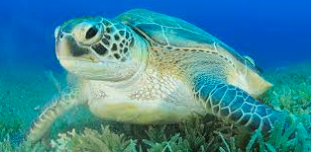 The global status of the green sea turtle was recently downgraded from Endangered to Least Concern by the International Union for Conservation of Nature (IUCN) in October 2025, following a 28% population increase since the 1970s due to decades of conservation efforts.

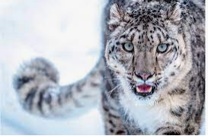 Snow leopards are currently classified as Vulnerable on the IUCN Red List of Threatened Species, a status they have held since 2017. This designation was adopted after a re-assessment determined that the global population of mature individuals exceeds 2,500 (estimated between 4,080 and 6,590 or up to 7,500) and is not declining at the rapid rate required for an "Endangered" classification.
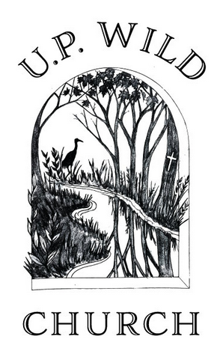
+ U.P. Wild Church is a faith community and spiritual home for building healing relationships.
We are cross- denominational and strive to listen and respond to the spiritual needs of those outside of traditional church contexts. Deep within the Christian tradition there is a wealth of wisdom on how to be good stewards of our natural environment. There are 8 branches across the Upper Peninsula offering wilderness walks, nature prayer services, and community-based offerings.
For more information: www.upwild.org

