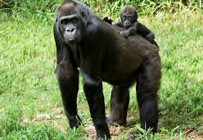
You are spiritually adopting this species on either the Critically Endangered or Endangered List: Lowland Gorilla – The Western Lowland Gorilla is the most widespread of all gorilla subspecies. The exact number is not known because they live in the most remote and dense forests in Africa. Poaching and disease have reduced the gorilla’s numbers by more than 60%. Scientists estimate that if we begin a recovery program now it will take 75 years to bring this species back to a recovery status.

Biologists have classified about 1.7 million species of plants and animals currently alive on this planet not including all the little bugs and bacteria. Every year this number is diminishes. The factors for this loss include: deforestation & habitat loss, pollution, overconsumption, & invasive species. So, here at U.P. Wild Church we believe it is time to fall back in love with them. It will be through our love that we will be better at living into a lifestyle that gives all life on the planet the ability to live as God intended.

Get to know your animal better
Head to the local library and find a book on your animal.
Watch a documentary.
Draw your own picture of them or imagine what their lives are like through art.

How to pray for your adopted animal
Every day or evening for as long as you decide,
make 5 minutes of time to center your prayer for your adopted animal.
This can be a simple intention for protection or lighting a candle.
We offer a suggested reflection & prayers:

A Wilderness Wisdom Reading from Job 12.7-10: “Ask the animals and they will teach you; the birds of the air, and they will teach you; ask the plants of the earth and they will teach you; and the fish of the sea will declare to you. Who does not know that the hand of the Creator has done this? In that hand is the life of every living thing, and the breath of every human being.” // “On the face of it, this seems a simple thing to do: consult the creatures of the earth and listen to the wisdom they impart. The effort to approach other species with concentrated attention to their story in all its struggle and delight creates an important shift in perspective. It entails stepping outside the usual theological conversation with its presumption of human superiority in order to place a different ‘other’ at the center of attention. The focus shifts to those who have been silenced, so that their voices are heard and we see (and feel) that each has an intrinsic value in their own right. The deep affection shown to us by the animals in our lives becomes an indivisible part of who we are. For love does not diminish the more we are in its presence, it only grows stronger and more radiant. We are called to fall back in love with the red-eyed tree frog, the black rhino and the hawksbill turtle, which are facing critical extinction. By loving that which God has created, out of the same breathe of life in which we were created, we liberate ourselves- we free ourselves from the isolation and loneliness of a culture of consumption that places primary value on man-made things. Instead, we become God’s subjects; a part of a living breathing eco-system; a community of friends;
each bearing witness (in their own way) to holiness.”
A moment of prayer…

Prayer Intentions:
I give thanks for our Earth which is a sanctuary filled with God’s presence,
a home for us to share with all of creation.
Creating God, hear my prayer

I pray for all those animals & plants, which are facing critical extinction including
[insert your animal’s name] and ask for the guidance to fall back in love with them so that we can remember we are first and foremost called to be good stewards and protectors of forests.
Creating God, hear my prayer

I ask for wisdom to address these problems, courage to make the changes needed, and prophetic persistence to keep striving toward healing for all your creation.
Creating God, hear my prayer

I pray for the people of this area including all native wildlife and biology of this [Great Lakes] region.
Creating God, hear my prayer

Guide me in my time of prayer and stir up my heart so that I may hear and follow
Your will in awakening to the ancient call to care for your Earth.
Creating God, hear my prayer

Thank you for creating the [insert your animal’s name]. Please hear their cries from the wilderness, provide for their needs, and the future generations of their species.
Creating God, hear their prayer

Let me learn from the prayer of the tortoise: “A little patience, O God, I am coming.
One must take nature as she is! It was not I who made her! I do not mean to criticize this house on my back- it has its points- but You must admit, Lord, it is heavy to carry! Still, let us hope that this double enclosure, my shell and my heart, will never be quite shut to You.”
Creating God, hear their prayer

For your prayer intention say it aloud or hold it in the silence of your heart.
Creating God, hear our prayer. Amen.

A Closing Poem by Emily Dickinson
If I can stop one heart from breaking, I shall not live in vain; If I can ease one life the aching, or cool one pain, Or help one fainting robin, on to his nest again, I shall not live in vain.
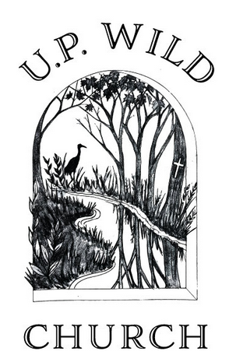

+ U.P. Wild Church is a faith community and spiritual home for building healing relationships. We are cross-denominational and strive to listen and respond to the spiritual needs of those outside of traditional church contexts. Deep within the Christian tradition there is a wealth of wisdom on how to be good stewards of our natural environment. No matter our background, we are all united in that we have been touched by a little creature at some point in our lives. We’ve felt their companionship and shared a connection of love – and that love is unifying. Indeed, it is capable of extending out into all of creation; even those beings we don’t see on a daily basis including our adopted species. For more information: www.upwild.org
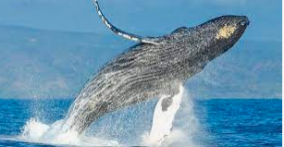
You are spiritually adopting this species on either the Critically Endangered or Endangered List: Blue Whale – The Blue Whale is the largest animal on the planet, weighing as much as 200 tons. That would be equivalent to the weight of 33 elephants. They are the loudest animals on the planet said to be louder than the noise a jet plane can make. Their calls can be heard by other whales for hundreds of miles. The whales are being seriously impacted by pollution plastic. They are important to the food chain of all marine animals.

Biologists have classified about 1.7 million species of plants and animals currently alive on this planet not including all the little bugs and bacteria. Every year this number is diminishes. The factors for this loss include: deforestation & habitat loss, pollution, overconsumption, & invasive species. So, here at U.P. Wild Church we believe it is time to fall back in love with them. It will be through our love that we will be better at living into a lifestyle that gives all life on the planet the ability to live as God intended.

Get to know your animal better
Head to the local library and find a book on your animal.
Watch a documentary.
Draw your own picture of them or imagine what their lives are like through art.

How to pray for your adopted animal
Every day or evening for as long as you decide,
make 5 minutes of time to center your prayer for your adopted animal.
This can be a simple intention for protection or lighting a candle.
We offer a suggested reflection & prayers:

A Wilderness Wisdom Reading from Job 12.7-10: “Ask the animals and they will teach you; the birds of the air, and they will teach you; ask the plants of the earth and they will teach you; and the fish of the sea will declare to you. Who does not know that the hand of the Creator has done this? In that hand is the life of every living thing, and the breath of every human being.” // “On the face of it, this seems a simple thing to do: consult the creatures of the earth and listen to the wisdom they impart. The effort to approach other species with concentrated attention to their story in all its struggle and delight creates an important shift in perspective. It entails stepping outside the usual theological conversation with its presumption of human superiority in order to place a different ‘other’ at the center of attention. The focus shifts to those who have been silenced, so that their voices are heard and we see (and feel) that each has an intrinsic value in their own right. The deep affection shown to us by the animals in our lives becomes an indivisible part of who we are. For love does not diminish the more we are in its presence, it only grows stronger and more radiant. We are called to fall back in love with the red-eyed tree frog, the black rhino and the hawksbill turtle, which are facing critical extinction. By loving that which God has created, out of the same breathe of life in which we were created, we liberate ourselves- we free ourselves from the isolation and loneliness of a culture of consumption that places primary value on man-made things. Instead, we become God’s subjects; a part of a living breathing eco-system; a community of friends;
each bearing witness (in their own way) to holiness.”

A moment of prayer…

Prayer Intentions:
I give thanks for our Earth which is a sanctuary filled with God’s presence,
a home for us to share with all of creation.
Creating God, hear my prayer

I pray for all those animals & plants, which are facing critical extinction including
[insert your animal’s name] and ask for the guidance to fall back in love with them so that we can remember we are first and foremost called to be good stewards and protectors of oceans.
Creating God, hear my prayer

I ask for wisdom to address these problems, courage to make the changes needed, and prophetic persistence to keep striving toward healing for all your creation.
Creating God, hear my prayer

I pray for the people of this area including all native wildlife and biology of this [Great Lakes] region.
Creating God, hear my prayer

Guide me in my time of prayer and stir up my heart so that I may hear and follow
Your will in awakening to the ancient call to care for your Earth.
Creating God, hear my prayer

Thank you for creating the [insert your animal’s name]. Please hear their cries from the wilderness, provide for their needs, and the future generations of their species.
Creating God, hear their prayer

Let me learn from the prayer of the tortoise: “A little patience, O God, I am coming.
One must take nature as she is! It was not I who made her! I do not mean to criticize this house on my back- it has its points- but You must admit, Lord, it is heavy to carry! Still, let us hope that this double enclosure, my shell and my heart, will never be quite shut to You.”
Creating God, hear their prayer

For your prayer intention say it aloud or hold it in the silence of your heart.
Creating God, hear our prayer. Amen.

A Closing Poem by Emily Dickinson
If I can stop one heart from breaking, I shall not live in vain; If I can ease one life the aching, or cool one pain, Or help one fainting robin, on to his nest again, I shall not live in vain.

+ U.P. Wild Church is a faith community and spiritual home for building healing relationships. We are cross-denominational and strive to listen and respond to the spiritual needs of those outside of traditional church contexts. Deep within the Christian tradition there is a wealth of wisdom on how to be good stewards of our natural environment. No matter our background, we are all united in that we have been touched by a little creature at some point in our lives. We’ve felt their companionship and shared a connection of love – and that love is unifying. Indeed, it is capable of extending out into all of creation; even those beings we don’t see on a daily basis including our adopted species. For more information: www.upwild.org
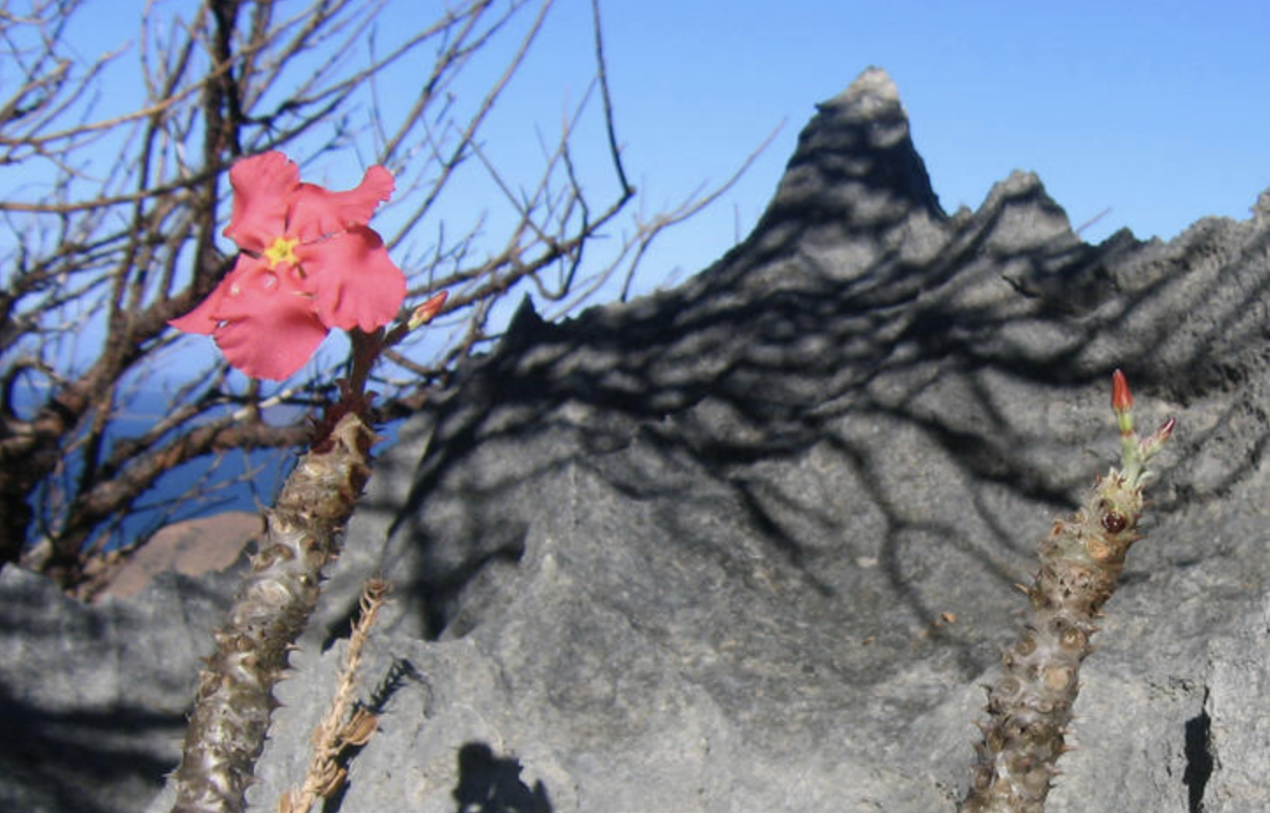
Vontaka is the common Malagasy name for several species of succulent trees in Madagascar. These plants are characterized by their thick, water-storing trunks and spiny branches, often growing on rocks in arid regions. The sap and bark are traditionally used by the Mikea people of southwestern Madagascar for making bark cloth, while the wood fiber was used for rope making.

Biologists have classified about 1.7 million species of plants and animals currently alive on this planet not including all the little bugs and bacteria. Every year this number is diminishes. The factors for this loss include: deforestation & habitat loss, pollution, overconsumption, & invasive species. So, here at U.P. Wild Church we believe it is time to fall back in love with them. It will be through our love that we will be better at living into a lifestyle that gives all life on the planet the ability to live as God intended.

Get to know your plant better
Head to the local library and find a book on your plant.
Watch a documentary.
Draw your own picture of them or imagine what their lives are like through art.

How to pray for your adopted plant
Every day or evening for as long as you decide,
make 5 minutes of time to center your prayer for your adopted plant.
This can be a simple intention for protection or lighting a candle.
We offer a suggested reflection & prayers:

A Wilderness Wisdom Reading from Job 12.7-10: “Ask the animals and they will teach you; the birds of the air, and they will teach you; ask the plants of the earth and they will teach you; and the fish of the sea will declare to you. Who does not know that the hand of the Creator has done this? In that hand is the life of every living thing, and the breath of every human being.” // “On the face of it, this seems a simple thing to do: consult the creatures of the earth and listen to the wisdom they impart. The effort to approach other species with concentrated attention to their story in all its struggle and delight creates an important shift in perspective. It entails stepping outside the usual theological conversation with its presumption of human superiority in order to place a different ‘other’ at the center of attention. The focus shifts to those who have been silenced, so that their voices are heard and we see (and feel) that each has an intrinsic value in their own right. The deep affection shown to us by the animals in our lives becomes an indivisible part of who we are. For love does not diminish the more we are in its presence, it only grows stronger and more radiant. We are called to fall back in love with the red-eyed tree frog, the black rhino and the hawksbill turtle, which are facing critical extinction. By loving that which God has created, out of the same breathe of life in which we were created, we liberate ourselves- we free ourselves from the isolation and loneliness of a culture of consumption that places primary value on man-made things. Instead, we become God’s subjects; a part of a living breathing eco-system; a community of friends;
each bearing witness (in their own way) to holiness.”

A moment of prayer…

Prayer Intentions:
I give thanks for our Earth which is a sanctuary filled with God’s presence,
a home for us to share with all of creation.
Creating God, hear my prayer

I pray for all those animals & plants, which are facing critical extinction including
[insert your plant’s name] and ask for the guidance to fall back in love with them so that we can remember we are first and foremost called to be good stewards and protectors of rocky cliffs.
Creating God, hear my prayer

I ask for wisdom to address these problems, courage to make the changes needed, and prophetic persistence to keep striving toward healing for all your creation.
Creating God, hear my prayer

I pray for the people of this area including all native wildlife and biology of this [Great Lakes] region.
Creating God, hear my prayer

Guide me in my time of prayer and stir up my heart so that I may hear and follow
Your will in awakening to the ancient call to care for your Earth.
Creating God, hear my prayer

Thank you for creating the [insert your plant’s name]. Please hear their cries from the wilderness, provide for their needs, and the future generations of their species.
Creating God, hear their prayer

Let me learn from the prayer of the tortoise: “A little patience, O God, I am coming.
One must take nature as she is! It was not I who made her! I do not mean to criticize this house on my back- it has its points- but You must admit, Lord, it is heavy to carry! Still, let us hope that this double enclosure, my shell and my heart, will never be quite shut to You.”
Creating God, hear their prayer

For your prayer intention say it aloud or hold it in the silence of your heart.
Creating God, hear our prayer. Amen.

A Closing Poem by Emily Dickinson
If I can stop one heart from breaking, I shall not live in vain; If I can ease one life the aching, or cool one pain, Or help one fainting robin, on to his nest again, I shall not live in vain.

+ U.P. Wild Church is a faith community and spiritual home for building healing relationships. We are cross-denominational and strive to listen and respond to the spiritual needs of those outside of traditional church contexts. Deep within the Christian tradition there is a wealth of wisdom on how to be good stewards of our natural environment. No matter our background, we are all united in that we have been touched by a little creature at some point in our lives. We’ve felt their companionship and shared a connection of love – and that love is unifying. Indeed, it is capable of extending out into all of creation; even those beings we don’t see on a daily basis including our adopted species. For more information: www.upwild.org
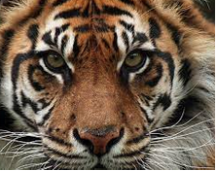
You are spiritually adopting this species on either the Critically Endangered or Endangered List: Sunda Tiger – This species was once found across all of the Sunda Islands and now are found only in Sumatra. The tigers that were in Java and Bali have now become extinct. There are now 400-600 of the Sunda Tigers and those are barely holding on for survival in the remaining patches of forest in Sumatra. Accelerating deforestation and poaching are the main causes for this threat. There have been efforts at strengthening law enforcement but the black market demand is high.

Biologists have classified about 1.7 million species of plants and animals currently alive on this planet not including all the little bugs and bacteria. Every year this number is diminishes. The factors for this loss include: deforestation & habitat loss, pollution, overconsumption, & invasive species. So, here at U.P. Wild Church we believe it is time to fall back in love with them. It will be through our love that we will be better at living into a lifestyle that gives all life on the planet the ability to live as God intended.

Get to know your animal better
Head to the local library and find a book on your animal.
Watch a documentary.
Draw your own picture of them or imagine what their lives are like through art.

How to pray for your adopted animal
Every day or evening for as long as you decide,
make 5 minutes of time to center your prayer for your adopted animal.
This can be a simple intention for protection or lighting a candle.
We offer a suggested reflection & prayers:

A Wilderness Wisdom Reading from Job 12.7-10: “Ask the animals and they will teach you; the birds of the air, and they will teach you; ask the plants of the earth and they will teach you; and the fish of the sea will declare to you. Who does not know that the hand of the Creator has done this? In that hand is the life of every living thing, and the breath of every human being.” // “On the face of it, this seems a simple thing to do: consult the creatures of the earth and listen to the wisdom they impart. The effort to approach other species with concentrated attention to their story in all its struggle and delight creates an important shift in perspective. It entails stepping outside the usual theological conversation with its presumption of human superiority in order to place a different ‘other’ at the center of attention. The focus shifts to those who have been silenced, so that their voices are heard and we see (and feel) that each has an intrinsic value in their own right. The deep affection shown to us by the animals in our lives becomes an indivisible part of who we are. For love does not diminish the more we are in its presence, it only grows stronger and more radiant. We are called to fall back in love with the red-eyed tree frog, the black rhino and the hawksbill turtle, which are facing critical extinction. By loving that which God has created, out of the same breathe of life in which we were created, we liberate ourselves- we free ourselves from the isolation and loneliness of a culture of consumption that places primary value on man-made things. Instead, we become God’s subjects; a part of a living breathing eco-system; a community of friends;
each bearing witness (in their own way) to holiness.”
A moment of prayer…

Prayer Intentions:
I give thanks for our Earth which is a sanctuary filled with God’s presence,
a home for us to share with all of creation.
Creating God, hear my prayer

I pray for all those animals & plants, which are facing critical extinction including
[insert your animal’s name] and ask for the guidance to fall back in love with them so that we can remember we are first and foremost called to be good stewards and protectors of forests.
Creating God, hear my prayer

I ask for wisdom to address these problems, courage to make the changes needed, and prophetic persistence to keep striving toward healing for all your creation.
Creating God, hear my prayer

I pray for the people of this area including all native wildlife and biology of this [Great Lakes] region.
Creating God, hear my prayer

Guide me in my time of prayer and stir up my heart so that I may hear and follow
Your will in awakening to the ancient call to care for your Earth.
Creating God, hear my prayer

Thank you for creating the [insert your animal’s name]. Please hear their cries from the wilderness, provide for their needs, and the future generations of their species.
Creating God, hear their prayer

Let me learn from the prayer of the tortoise: “A little patience, O God, I am coming.
One must take nature as she is! It was not I who made her! I do not mean to criticize this house on my back- it has its points- but You must admit, Lord, it is heavy to carry! Still, let us hope that this double enclosure, my shell and my heart, will never be quite shut to You.”
Creating God, hear their prayer

For your prayer intention say it aloud or hold it in the silence of your heart.
Creating God, hear our prayer. Amen.

A Closing Poem by Emily Dickinson
If I can stop one heart from breaking, I shall not live in vain; If I can ease one life the aching, or cool one pain, Or help one fainting robin, on to his nest again, I shall not live in vain.

+ U.P. Wild Church is a faith community and spiritual home for building healing relationships. We are cross-denominational and strive to listen and respond to the spiritual needs of those outside of traditional church contexts. Deep within the Christian tradition there is a wealth of wisdom on how to be good stewards of our natural environment. No matter our background, we are all united in that we have been touched by a little creature at some point in our lives. We’ve felt their companionship and shared a connection of love – and that love is unifying. Indeed, it is capable of extending out into all of creation; even those beings we don’t see on a daily basis including our adopted species. For more information: www.upwild.org

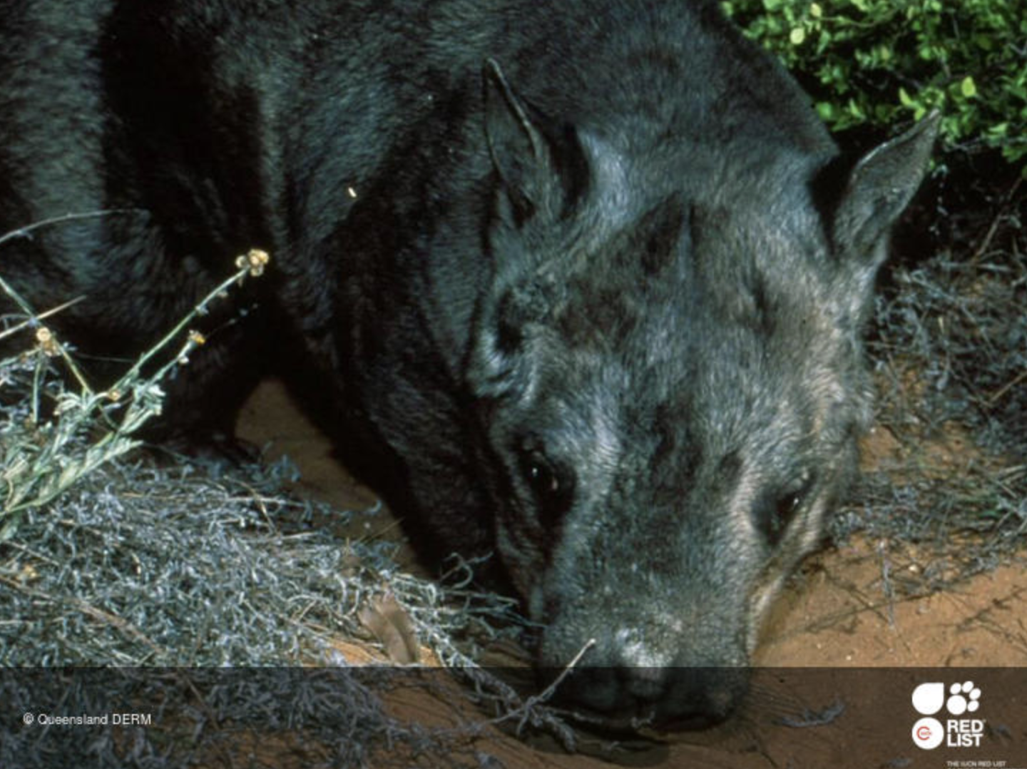

The northern hairy-nosed wombat is one of three species of Australian marsupials known as wombats. It is one of the rarest land mammals in the world. The current population is 115 animals in 2018 and possibly now only 80. The population had fallen as low as 30-40 individuals in the early 1980s, but the exclusion of cattle from its range led to a steady increase in numbers. Periods of drought can greatly reduce the population. In 2000, Dingoes eliminated 15-20 individuals and a 20-km-long fence now encompasses the entire population.

Biologists have classified about 1.7 million species of plants and animals currently alive on this planet not including all the little bugs and bacteria. Every year this number is diminishes. The factors for this loss include: deforestation & habitat loss, pollution, overconsumption, & invasive species. So, here at U.P. Wild Church we believe it is time to fall back in love with them. It will be through our love that we will be better at living into a lifestyle that gives all life on the planet the ability to live as God intended.

Get to know your animal better
Head to the local library and find a book on your animal.
Watch a documentary.
Draw your own picture of them or imagine what their lives are like through art.

How to pray for your adopted animal
Every day or evening for as long as you decide,
make 5 minutes of time to center your prayer for your adopted animal.
This can be a simple intention for protection or lighting a candle.
We offer a suggested reflection & prayers:

A Wilderness Wisdom Reading from Job 12.7-10: “Ask the animals and they will teach you; the birds of the air, and they will teach you; ask the plants of the earth and they will teach you; and the fish of the sea will declare to you. Who does not know that the hand of the Creator has done this? In that hand is the life of every living thing, and the breath of every human being.” // “On the face of it, this seems a simple thing to do: consult the creatures of the earth and listen to the wisdom they impart. The effort to approach other species with concentrated attention to their story in all its struggle and delight creates an important shift in perspective. It entails stepping outside the usual theological conversation with its presumption of human superiority in order to place a different ‘other’ at the center of attention. The focus shifts to those who have been silenced, so that their voices are heard and we see (and feel) that each has an intrinsic value in their own right. The deep affection shown to us by the animals in our lives becomes an indivisible part of who we are. For love does not diminish the more we are in its presence, it only grows stronger and more radiant. We are called to fall back in love with the red-eyed tree frog, the black rhino and the hawksbill turtle, which are facing critical extinction. By loving that which God has created, out of the same breathe of life in which we were created, we liberate ourselves- we free ourselves from the isolation and loneliness of a culture of consumption that places primary value on man-made things. Instead, we become God’s subjects; a part of a living breathing eco-system; a community of friends;
each bearing witness (in their own way) to holiness.”
A moment of prayer…

Prayer Intentions:
I give thanks for our Earth which is a sanctuary filled with God’s presence,
a home for us to share with all of creation.
Creating God, hear my prayer

I pray for all those animals & plants, which are facing critical extinction including
[insert your animal’s name] and ask for the guidance to fall back in love with them so that we can remember we are first and foremost called to be good stewards and protectors of savannas.
Creating God, hear my prayer

I ask for wisdom to address these problems, courage to make the changes needed, and prophetic persistence to keep striving toward healing for all your creation.
Creating God, hear my prayer

I pray for the people of this area including all native wildlife and biology of this [Great Lakes] region.
Creating God, hear my prayer

Guide me in my time of prayer and stir up my heart so that I may hear and follow
Your will in awakening to the ancient call to care for your Earth.
Creating God, hear my prayer

Thank you for creating the [insert your animal’s name]. Please hear their cries from the wilderness, provide for their needs, and the future generations of their species.
Creating God, hear their prayer

Let me learn from the prayer of the tortoise: “A little patience, O God, I am coming.
One must take nature as she is! It was not I who made her! I do not mean to criticize this house on my back- it has its points- but You must admit, Lord, it is heavy to carry! Still, let us hope that this double enclosure, my shell and my heart, will never be quite shut to You.”
Creating God, hear their prayer

For your prayer intention say it aloud or hold it in the silence of your heart.
Creating God, hear our prayer. Amen.

A Closing Poem by Emily Dickinson
If I can stop one heart from breaking, I shall not live in vain; If I can ease one life the aching, or cool one pain, Or help one fainting robin, on to his nest again, I shall not live in vain.

+ U.P. Wild Church is a faith community and spiritual home for building healing relationships. We are cross-denominational and strive to listen and respond to the spiritual needs of those outside of traditional church contexts. Deep within the Christian tradition there is a wealth of wisdom on how to be good stewards of our natural environment. No matter our background, we are all united in that we have been touched by a little creature at some point in our lives. We’ve felt their companionship and shared a connection of love – and that love is unifying. Indeed, it is capable of extending out into all of creation; even those beings we don’t see on a daily basis including our adopted species. For more information: www.upwild.org
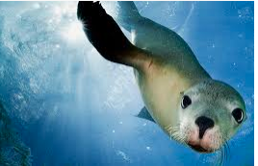
You are spiritually adopting this species on either the Critically Endangered or Endangered List: Sea Lions – Sea Lions are the big (up to 400 pounds), loveable creatures that haul out in colonies to lie around on ocean rock. They love to bask in the sun! Australian, Galapagos and New Zealand sea lions are most at threat due to entanglement in fishing gear, exposure to biotoxins from harmful algal blooms, and human-related injuries and mortality.

Biologists have classified about 1.7 million species of plants and animals currently alive on this planet not including all the little bugs and bacteria. Every year this number is diminishes. The factors for this loss include: deforestation & habitat loss, pollution, overconsumption, & invasive species. So, here at U.P. Wild Church we believe it is time to fall back in love with them. It will be through our love that we will be better at living into a lifestyle that gives all life on the planet the ability to live as God intended.

Get to know your animal better
Head to the local library and find a book on your animal.
Watch a documentary.
Draw your own picture of them or imagine what their lives are like through art.

How to pray for your adopted animal
Every day or evening for as long as you decide,
make 5 minutes of time to center your prayer for your adopted animal.
This can be a simple intention for protection or lighting a candle.
We offer a suggested reflection & prayers:

A Wilderness Wisdom Reading from Job 12.7-10: “Ask the animals and they will teach you; the birds of the air, and they will teach you; ask the plants of the earth and they will teach you; and the fish of the sea will declare to you. Who does not know that the hand of the Creator has done this? In that hand is the life of every living thing, and the breath of every human being.” // “On the face of it, this seems a simple thing to do: consult the creatures of the earth and listen to the wisdom they impart. The effort to approach other species with concentrated attention to their story in all its struggle and delight creates an important shift in perspective. It entails stepping outside the usual theological conversation with its presumption of human superiority in order to place a different ‘other’ at the center of attention. The focus shifts to those who have been silenced, so that their voices are heard and we see (and feel) that each has an intrinsic value in their own right. The deep affection shown to us by the animals in our lives becomes an indivisible part of who we are. For love does not diminish the more we are in its presence, it only grows stronger and more radiant. We are called to fall back in love with the red-eyed tree frog, the black rhino and the hawksbill turtle, which are facing critical extinction. By loving that which God has created, out of the same breathe of life in which we were created, we liberate ourselves- we free ourselves from the isolation and loneliness of a culture of consumption that places primary value on man-made things. Instead, we become God’s subjects; a part of a living breathing eco-system; a community of friends;
each bearing witness (in their own way) to holiness.”

A moment of prayer…

Prayer Intentions:
I give thanks for our Earth which is a sanctuary filled with God’s presence,
a home for us to share with all of creation.
Creating God, hear my prayer

I pray for all those animals & plants, which are facing critical extinction including
[insert your animal’s name] and ask for the guidance to fall back in love with them so that we can remember we are first and foremost called to be good stewards and protectors of seas.
Creating God, hear my prayer

I ask for wisdom to address these problems, courage to make the changes needed, and prophetic persistence to keep striving toward healing for all your creation.
Creating God, hear my prayer

I pray for the people of this area including all native wildlife and biology of this [Great Lakes] region.
Creating God, hear my prayer

Guide me in my time of prayer and stir up my heart so that I may hear and follow
Your will in awakening to the ancient call to care for your Earth.
Creating God, hear my prayer

Thank you for creating the [insert your animal’s name]. Please hear their cries from the wilderness, provide for their needs, and the future generations of their species.
Creating God, hear their prayer

Let me learn from the prayer of the tortoise: “A little patience, O God, I am coming.
One must take nature as she is! It was not I who made her! I do not mean to criticize this house on my back- it has its points- but You must admit, Lord, it is heavy to carry! Still, let us hope that this double enclosure, my shell and my heart, will never be quite shut to You.”
Creating God, hear their prayer

For your prayer intention say it aloud or hold it in the silence of your heart.
Creating God, hear our prayer. Amen.

A Closing Poem by Emily Dickinson
If I can stop one heart from breaking, I shall not live in vain; If I can ease one life the aching, or cool one pain, Or help one fainting robin, on to his nest again, I shall not live in vain.

+ U.P. Wild Church is a faith community and spiritual home for building healing relationships. We are cross-denominational and strive to listen and respond to the spiritual needs of those outside of traditional church contexts. Deep within the Christian tradition there is a wealth of wisdom on how to be good stewards of our natural environment. No matter our background, we are all united in that we have been touched by a little creature at some point in our lives. We’ve felt their companionship and shared a connection of love – and that love is unifying. Indeed, it is capable of extending out into all of creation; even those beings we don’t see on a daily basis including our adopted species. For more information: www.upwild.org
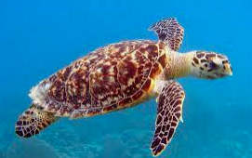
You are spiritually adopting this species on either the Critically Endangered or Endangered List: Hawksbill Sea Turtle – Hawksbills are named for their pointed beaks. Their beautiful colored shells make them very valuable as tortoiseshell in the market place. They may be found in any tropical region but predominately near coral reefs. They feed on sponges, but also eat jellyfish. They are among the oldest reptiles on earth and have existed for the last 100 million years. They are a very important link in the marine eco system. Hawksbills are threatened by the loss of nesting and feeding grounds, pollution, and coastal development. Their biggest threat is wildlife trade.

Biologists have classified about 1.7 million species of plants and animals currently alive on this planet not including all the little bugs and bacteria. Every year this number is diminishes. The factors for this loss include: deforestation & habitat loss, pollution, overconsumption, & invasive species. So, here at U.P. Wild Church we believe it is time to fall back in love with them. It will be through our love that we will be better at living into a lifestyle that gives all life on the planet the ability to live as God intended.

Get to know your animal better
Head to the local library and find a book on your animal.
Watch a documentary.
Draw your own picture of them or imagine what their lives are like through art.

How to pray for your adopted animal
Every day or evening for as long as you decide,
make 5 minutes of time to center your prayer for your adopted animal.
This can be a simple intention for protection or lighting a candle.
We offer a suggested reflection & prayers:

A Wilderness Wisdom Reading from Job 12.7-10: “Ask the animals and they will teach you; the birds of the air, and they will teach you; ask the plants of the earth and they will teach you; and the fish of the sea will declare to you. Who does not know that the hand of the Creator has done this? In that hand is the life of every living thing, and the breath of every human being.” // “On the face of it, this seems a simple thing to do: consult the creatures of the earth and listen to the wisdom they impart. The effort to approach other species with concentrated attention to their story in all its struggle and delight creates an important shift in perspective. It entails stepping outside the usual theological conversation with its presumption of human superiority in order to place a different ‘other’ at the center of attention. The focus shifts to those who have been silenced, so that their voices are heard and we see (and feel) that each has an intrinsic value in their own right. The deep affection shown to us by the animals in our lives becomes an indivisible part of who we are. For love does not diminish the more we are in its presence, it only grows stronger and more radiant. We are called to fall back in love with the red-eyed tree frog, the black rhino and the hawksbill turtle, which are facing critical extinction. By loving that which God has created, out of the same breathe of life in which we were created, we liberate ourselves- we free ourselves from the isolation and loneliness of a culture of consumption that places primary value on man-made things. Instead, we become God’s subjects; a part of a living breathing eco-system; a community of friends;
each bearing witness (in their own way) to holiness.”
A moment of prayer…

Prayer Intentions:
I give thanks for our Earth which is a sanctuary filled with God’s presence,
a home for us to share with all of creation.
Creating God, hear my prayer

I pray for all those animals & plants, which are facing critical extinction including
[insert your animal’s name] and ask for the guidance to fall back in love with them so that we can remember we are first and foremost called to be good stewards and protectors of oceans.
Creating God, hear my prayer

I ask for wisdom to address these problems, courage to make the changes needed, and prophetic persistence to keep striving toward healing for all your creation.
Creating God, hear my prayer

I pray for the people of this area including all native wildlife and biology of this [Great Lakes] region.
Creating God, hear my prayer

Guide me in my time of prayer and stir up my heart so that I may hear and follow
Your will in awakening to the ancient call to care for your Earth.
Creating God, hear my prayer

Thank you for creating the [insert your animal’s name]. Please hear their cries from the wilderness, provide for their needs, and the future generations of their species.
Creating God, hear their prayer

Let me learn from the prayer of the tortoise: “A little patience, O God, I am coming.
One must take nature as she is! It was not I who made her! I do not mean to criticize this house on my back- it has its points- but You must admit, Lord, it is heavy to carry! Still, let us hope that this double enclosure, my shell and my heart, will never be quite shut to You.”
Creating God, hear their prayer

For your prayer intention say it aloud or hold it in the silence of your heart.
Creating God, hear our prayer. Amen.

A Closing Poem by Emily Dickinson
If I can stop one heart from breaking, I shall not live in vain; If I can ease one life the aching, or cool one pain, Or help one fainting robin, on to his nest again, I shall not live in vain.

+ U.P. Wild Church is a faith community and spiritual home for building healing relationships. We are cross-denominational and strive to listen and respond to the spiritual needs of those outside of traditional church contexts. Deep within the Christian tradition there is a wealth of wisdom on how to be good stewards of our natural environment. No matter our background, we are all united in that we have been touched by a little creature at some point in our lives. We’ve felt their companionship and shared a connection of love – and that love is unifying. Indeed, it is capable of extending out into all of creation; even those beings we don’t see on a daily basis including our adopted species. For more information: www.upwild.org
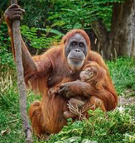
You are spiritually adopting this species on either the Critically Endangered or Endangered List: Sumatran Orangutan – This name derived from the Malay words meaning “person of the forest”. They live almost entirely in the tops of tropical trees. They maintain very close social ties. Illegal trade on the pet market has been a major factor in their decline as well as deforestation for palm oil. Orangutans are major seed spreaders and if they disappeared so would several species of trees. Loss of forests due to fire and the change from forest land to farming also has a big impact. If even 1% of the female population is lost each year, they will be extinct very quickly.

Biologists have classified about 1.7 million species of plants and animals currently alive on this planet not including all the little bugs and bacteria. Every year this number is diminishes. The factors for this loss include: deforestation & habitat loss, pollution, overconsumption, & invasive species. So, here at U.P. Wild Church we believe it is time to fall back in love with them. It will be through our love that we will be better at living into a lifestyle that gives all life on the planet the ability to live as God intended.

Get to know your animal better
Head to the local library and find a book on your animal.
Watch a documentary.
Draw your own picture of them or imagine what their lives are like through art.

How to pray for your adopted animal
Every day or evening for as long as you decide,
make 5 minutes of time to center your prayer for your adopted animal.
This can be a simple intention for protection or lighting a candle.
We offer a suggested reflection & prayers:

A Wilderness Wisdom Reading from Job 12.7-10: “Ask the animals and they will teach you; the birds of the air, and they will teach you; ask the plants of the earth and they will teach you; and the fish of the sea will declare to you. Who does not know that the hand of the Creator has done this? In that hand is the life of every living thing, and the breath of every human being.” // “On the face of it, this seems a simple thing to do: consult the creatures of the earth and listen to the wisdom they impart. The effort to approach other species with concentrated attention to their story in all its struggle and delight creates an important shift in perspective. It entails stepping outside the usual theological conversation with its presumption of human superiority in order to place a different ‘other’ at the center of attention. The focus shifts to those who have been silenced, so that their voices are heard and we see (and feel) that each has an intrinsic value in their own right. The deep affection shown to us by the animals in our lives becomes an indivisible part of who we are. For love does not diminish the more we are in its presence, it only grows stronger and more radiant. We are called to fall back in love with the red-eyed tree frog, the black rhino and the hawksbill turtle, which are facing critical extinction. By loving that which God has created, out of the same breathe of life in which we were created, we liberate ourselves- we free ourselves from the isolation and loneliness of a culture of consumption that places primary value on man-made things. Instead, we become God’s subjects; a part of a living breathing eco-system; a community of friends;
each bearing witness (in their own way) to holiness.”
A moment of prayer…

Prayer Intentions:
I give thanks for our Earth which is a sanctuary filled with God’s presence,
a home for us to share with all of creation.
Creating God, hear my prayer

I pray for all those animals & plants, which are facing critical extinction including
[insert your animal’s name] and ask for the guidance to fall back in love with them so that we can remember we are first and foremost called to be good stewards and protectors of forests.
Creating God, hear my prayer

I ask for wisdom to address these problems, courage to make the changes needed, and prophetic persistence to keep striving toward healing for all your creation.
Creating God, hear my prayer

I pray for the people of this area including all native wildlife and biology of this [Great Lakes] region.
Creating God, hear my prayer

Guide me in my time of prayer and stir up my heart so that I may hear and follow
Your will in awakening to the ancient call to care for your Earth.
Creating God, hear my prayer

Thank you for creating the [insert your animal’s name]. Please hear their cries from the wilderness, provide for their needs, and the future generations of their species.
Creating God, hear their prayer

Let me learn from the prayer of the tortoise: “A little patience, O God, I am coming.
One must take nature as she is! It was not I who made her! I do not mean to criticize this house on my back- it has its points- but You must admit, Lord, it is heavy to carry! Still, let us hope that this double enclosure, my shell and my heart, will never be quite shut to You.”
Creating God, hear their prayer

For your prayer intention say it aloud or hold it in the silence of your heart.
Creating God, hear our prayer. Amen.

A Closing Poem by Emily Dickinson
If I can stop one heart from breaking, I shall not live in vain; If I can ease one life the aching, or cool one pain, Or help one fainting robin, on to his nest again, I shall not live in vain.
+ U.P. Wild Church is a faith community and spiritual home for building healing relationships. We are cross-denominational and strive to listen and respond to the spiritual needs of those outside of traditional church contexts. Deep within the Christian tradition there is a wealth of wisdom on how to be good stewards of our natural environment. No matter our background, we are all united in that we have been touched by a little creature at some point in our lives. We’ve felt their companionship and shared a connection of love – and that love is unifying. Indeed, it is capable of extending out into all of creation; even those beings we don’t see on a daily basis including our adopted species. For more information: www.upwild.org
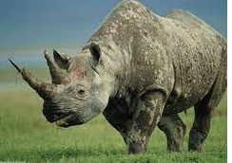
You are spiritually adopting this species on either the Critically Endangered or Endangered List: Eastern Black Rhinoceros – This is one of several subspecies of Black Rhinos, three of which have already become extinct. This enormous animal, weighing up to 3,000 pounds, once ruled southern Africa. Despite their size, they eat mainly leafy foliage. The gestation period for baby rhinos is 16 months and the babies will weigh up 300 pounds. Habitat loss, trophy hunting for its horn, and black-market Chinese medicine have been major factors. However, they are coming back with our help.

Biologists have classified about 1.7 million species of plants and animals currently alive on this planet not including all the little bugs and bacteria. Every year this number is diminishes. The factors for this loss include: deforestation & habitat loss, pollution, overconsumption, & invasive species. So, here at U.P. Wild Church we believe it is time to fall back in love with them. It will be through our love that we will be better at living into a lifestyle that gives all life on the planet the ability to live as God intended.

Get to know your animal better
Head to the local library and find a book on your animal.
Watch a documentary.
Draw your own picture of them or imagine what their lives are like through art.

How to pray for your adopted animal
Every day or evening for as long as you decide,
make 5 minutes of time to center your prayer for your adopted animal.
This can be a simple intention for protection or lighting a candle.
We offer a suggested reflection & prayers:

A Wilderness Wisdom Reading from Job 12.7-10: “Ask the animals and they will teach you; the birds of the air, and they will teach you; ask the plants of the earth and they will teach you; and the fish of the sea will declare to you. Who does not know that the hand of the Creator has done this? In that hand is the life of every living thing, and the breath of every human being.” // “On the face of it, this seems a simple thing to do: consult the creatures of the earth and listen to the wisdom they impart. The effort to approach other species with concentrated attention to their story in all its struggle and delight creates an important shift in perspective. It entails stepping outside the usual theological conversation with its presumption of human superiority in order to place a different ‘other’ at the center of attention. The focus shifts to those who have been silenced, so that their voices are heard and we see (and feel) that each has an intrinsic value in their own right. The deep affection shown to us by the animals in our lives becomes an indivisible part of who we are. For love does not diminish the more we are in its presence, it only grows stronger and more radiant. We are called to fall back in love with the red-eyed tree frog, the black rhino and the hawksbill turtle, which are facing critical extinction. By loving that which God has created, out of the same breathe of life in which we were created, we liberate ourselves- we free ourselves from the isolation and loneliness of a culture of consumption that places primary value on man-made things. Instead, we become God’s subjects; a part of a living breathing eco-system; a community of friends;
each bearing witness (in their own way) to holiness.”
A moment of prayer…

Prayer Intentions:
I give thanks for our Earth which is a sanctuary filled with God’s presence,
a home for us to share with all of creation.
Creating God, hear my prayer

I pray for all those animals & plants, which are facing critical extinction including
[insert your animal’s name] and ask for the guidance to fall back in love with them so that we can remember we are first and foremost called to be good stewards and protectors of savannas.
Creating God, hear my prayer

I ask for wisdom to address these problems, courage to make the changes needed, and prophetic persistence to keep striving toward healing for all your creation.
Creating God, hear my prayer

I pray for the people of this area including all native wildlife and biology of this [Great Lakes] region.
Creating God, hear my prayer

Guide me in my time of prayer and stir up my heart so that I may hear and follow
Your will in awakening to the ancient call to care for your Earth.
Creating God, hear my prayer

Thank you for creating the [insert your animal’s name]. Please hear their cries from the wilderness, provide for their needs, and the future generations of their species.
Creating God, hear their prayer

Let me learn from the prayer of the tortoise: “A little patience, O God, I am coming.
One must take nature as she is! It was not I who made her! I do not mean to criticize this house on my back- it has its points- but You must admit, Lord, it is heavy to carry! Still, let us hope that this double enclosure, my shell and my heart, will never be quite shut to You.”
Creating God, hear their prayer

For your prayer intention say it aloud or hold it in the silence of your heart.
Creating God, hear our prayer. Amen.

A Closing Poem by Emily Dickinson
If I can stop one heart from breaking, I shall not live in vain; If I can ease one life the aching, or cool one pain, Or help one fainting robin, on to his nest again, I shall not live in vain.

+ U.P. Wild Church is a faith community and spiritual home for building healing relationships. We are cross-denominational and strive to listen and respond to the spiritual needs of those outside of traditional church contexts. Deep within the Christian tradition there is a wealth of wisdom on how to be good stewards of our natural environment. No matter our background, we are all united in that we have been touched by a little creature at some point in our lives. We’ve felt their companionship and shared a connection of love – and that love is unifying. Indeed, it is capable of extending out into all of creation; even those beings we don’t see on a daily basis including our adopted species. For more information: www.upwild.org
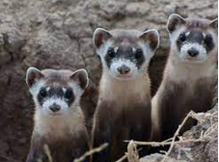
You are spiritually adopting this species on either the Critically Endangered or Endangered List: Black Footed Ferret – This two-foot long, black masked member of the weasel family once occurred in the grasslands from southern Canada to Texas, but was twice thought to be extinct during the 20th century. The causes were loss of habitat, poisoning and disease. They have been on the brink of extinction as recently as the late 1900’s, but seem now to be making a small comeback. Native American tribal groups have been major supporters of the efforts to help them survive. The estimate now is that there are approximately 200+ Black Footed Ferrets in the wild.

Biologists have classified about 1.7 million species of plants and animals currently alive on this planet not including all the little bugs and bacteria. Every year this number is diminishes. The factors for this loss include: deforestation & habitat loss, pollution, overconsumption, & invasive species. So, here at U.P. Wild Church we believe it is time to fall back in love with them. It will be through our love that we will be better at living into a lifestyle that gives all life on the planet the ability to live as God intended.

Get to know your animal better
Head to the local library and find a book on your animal.
Watch a documentary.
Draw your own picture of them or imagine what their lives are like through art.

How to pray for your adopted animal
Every day or evening for as long as you decide,
make 5 minutes of time to center your prayer for your adopted animal.
This can be a simple intention for protection or lighting a candle.
We offer a suggested reflection & prayers:

A Wilderness Wisdom Reading from Job 12.7-10: “Ask the animals and they will teach you; the birds of the air, and they will teach you; ask the plants of the earth and they will teach you; and the fish of the sea will declare to you. Who does not know that the hand of the Creator has done this? In that hand is the life of every living thing, and the breath of every human being.” // “On the face of it, this seems a simple thing to do: consult the creatures of the earth and listen to the wisdom they impart. The effort to approach other species with concentrated attention to their story in all its struggle and delight creates an important shift in perspective. It entails stepping outside the usual theological conversation with its presumption of human superiority in order to place a different ‘other’ at the center of attention. The focus shifts to those who have been silenced, so that their voices are heard and we see (and feel) that each has an intrinsic value in their own right. The deep affection shown to us by the animals in our lives becomes an indivisible part of who we are. For love does not diminish the more we are in its presence, it only grows stronger and more radiant. We are called to fall back in love with the red-eyed tree frog, the black rhino and the hawksbill turtle, which are facing critical extinction. By loving that which God has created, out of the same breathe of life in which we were created, we liberate ourselves- we free ourselves from the isolation and loneliness of a culture of consumption that places primary value on man-made things. Instead, we become God’s subjects; a part of a living breathing eco-system; a community of friends;
each bearing witness (in their own way) to holiness.”
A moment of prayer…

Prayer Intentions:
I give thanks for our Earth which is a sanctuary filled with God’s presence,
a home for us to share with all of creation.
Creating God, hear my prayer

I pray for all those animals & plants, which are facing critical extinction including
[insert your animal’s name] and ask for the guidance to fall back in love with them so that we can remember we are first and foremost called to be good stewards and protectors of shrubland.
Creating God, hear my prayer

I ask for wisdom to address these problems, courage to make the changes needed, and prophetic persistence to keep striving toward healing for all your creation.
Creating God, hear my prayer

I pray for the people of this area including all native wildlife and biology of this [Great Lakes] region.
Creating God, hear my prayer

Guide me in my time of prayer and stir up my heart so that I may hear and follow
Your will in awakening to the ancient call to care for your Earth.
Creating God, hear my prayer

Thank you for creating the [insert your animal’s name]. Please hear their cries from the wilderness, provide for their needs, and the future generations of their species.
Creating God, hear their prayer

Let me learn from the prayer of the tortoise: “A little patience, O God, I am coming.
One must take nature as she is! It was not I who made her! I do not mean to criticize this house on my back- it has its points- but You must admit, Lord, it is heavy to carry! Still, let us hope that this double enclosure, my shell and my heart, will never be quite shut to You.”
Creating God, hear their prayer

For your prayer intention say it aloud or hold it in the silence of your heart.
Creating God, hear our prayer. Amen.

A Closing Poem by Emily Dickinson
If I can stop one heart from breaking, I shall not live in vain; If I can ease one life the aching, or cool one pain, Or help one fainting robin, on to his nest again, I shall not live in vain.

+ U.P. Wild Church is a faith community and spiritual home for building healing relationships. We are cross-denominational and strive to listen and respond to the spiritual needs of those outside of traditional church contexts. Deep within the Christian tradition there is a wealth of wisdom on how to be good stewards of our natural environment. No matter our background, we are all united in that we have been touched by a little creature at some point in our lives. We’ve felt their companionship and shared a connection of love – and that love is unifying. Indeed, it is capable of extending out into all of creation; even those beings we don’t see on a daily basis including our adopted species. For more information: www.upwild.org
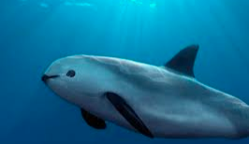
You are spiritually adopting this species on either the Critically Endangered or Endangered List: Vaquita, the world's rarest marine mammal, is on the edge of extinction. The plight of cetaceans—whales, dolphins, and porpoises—as a whole is in decline. This little porpoise wasn't discovered until 1958 and a little over half a century later, we are on the brink of losing them forever. Vaquita are often caught and drowned in gillnets used by illegal fishing operations in marine protected areas within Mexico's Gulf of California. The population is estimated at less than 20 on Earth.

Biologists have classified about 1.7 million species of plants and animals currently alive on this planet not including all the little bugs and bacteria. Every year this number is diminishes. The factors for this loss include: deforestation & habitat loss, pollution, overconsumption, & invasive species. So, here at U.P. Wild Church we believe it is time to fall back in love with them. It will be through our love that we will be better at living into a lifestyle that gives all life on the planet the ability to live as God intended.

Get to know your animal better
Head to the local library and find a book on your animal.
Watch a documentary.
Draw your own picture of them or imagine what their lives are like through art.

How to pray for your adopted animal
Every day or evening for as long as you decide,
make 5 minutes of time to center your prayer for your adopted animal.
This can be a simple intention for protection or lighting a candle.
We offer a suggested reflection & prayers:

A Wilderness Wisdom Reading from Job 12.7-10: “Ask the animals and they will teach you; the birds of the air, and they will teach you; ask the plants of the earth and they will teach you; and the fish of the sea will declare to you. Who does not know that the hand of the Creator has done this? In that hand is the life of every living thing, and the breath of every human being.” // “On the face of it, this seems a simple thing to do: consult the creatures of the earth and listen to the wisdom they impart. The effort to approach other species with concentrated attention to their story in all its struggle and delight creates an important shift in perspective. It entails stepping outside the usual theological conversation with its presumption of human superiority in order to place a different ‘other’ at the center of attention. The focus shifts to those who have been silenced, so that their voices are heard and we see (and feel) that each has an intrinsic value in their own right. The deep affection shown to us by the animals in our lives becomes an indivisible part of who we are. For love does not diminish the more we are in its presence, it only grows stronger and more radiant. We are called to fall back in love with the red-eyed tree frog, the black rhino and the hawksbill turtle, which are facing critical extinction. By loving that which God has created, out of the same breathe of life in which we were created, we liberate ourselves- we free ourselves from the isolation and loneliness of a culture of consumption that places primary value on man-made things. Instead, we become God’s subjects; a part of a living breathing eco-system; a community of friends;
each bearing witness (in their own way) to holiness.”

A moment of prayer…

Prayer Intentions:
I give thanks for our Earth which is a sanctuary filled with God’s presence,
a home for us to share with all of creation.
Creating God, hear my prayer

I pray for all those animals & plants, which are facing critical extinction including
[insert your animal’s name] and ask for the guidance to fall back in love with them so that we can remember we are first and foremost called to be good stewards and protectors of marine waters.
Creating God, hear my prayer

I ask for wisdom to address these problems, courage to make the changes needed, and prophetic persistence to keep striving toward healing for all your creation.
Creating God, hear my prayer

I pray for the people of this area including all native wildlife and biology of this [Great Lakes] region.
Creating God, hear my prayer

Guide me in my time of prayer and stir up my heart so that I may hear and follow
Your will in awakening to the ancient call to care for your Earth.
Creating God, hear my prayer

Thank you for creating the [insert your animal’s name]. Please hear their cries from the wilderness, provide for their needs, and the future generations of their species.
Creating God, hear their prayer

Let me learn from the prayer of the tortoise: “A little patience, O God, I am coming.
One must take nature as she is! It was not I who made her! I do not mean to criticize this house on my back- it has its points- but You must admit, Lord, it is heavy to carry! Still, let us hope that this double enclosure, my shell and my heart, will never be quite shut to You.”
Creating God, hear their prayer

For your prayer intention say it aloud or hold it in the silence of your heart.
Creating God, hear our prayer. Amen.

A Closing Poem by Emily Dickinson
If I can stop one heart from breaking, I shall not live in vain; If I can ease one life the aching, or cool one pain, Or help one fainting robin, on to his nest again, I shall not live in vain.

+ U.P. Wild Church is a faith community and spiritual home for building healing relationships. We are cross-denominational and strive to listen and respond to the spiritual needs of those outside of traditional church contexts. Deep within the Christian tradition there is a wealth of wisdom on how to be good stewards of our natural environment. No matter our background, we are all united in that we have been touched by a little creature at some point in our lives. We’ve felt their companionship and shared a connection of love – and that love is unifying. Indeed, it is capable of extending out into all of creation; even those beings we don’t see on a daily basis including our adopted species. For more information: www.upwild.org

